**GRADE 4- WEEK 2**

**UNIT 1 : They’re from Australia!**

**LESSON 1**

**VOCABULARY**

**Korea: nước Hàn Quốc**

**Viet Nam : nước Việt Nam**

**Mexico: nước Mê-Hi-Cô**

**Thailand: nước Thái Lan**

**Australia: nước Úc**

**The USA: nước Mỹ**

**Brazil: nước Bờ-ra-zin**

**Grammar**

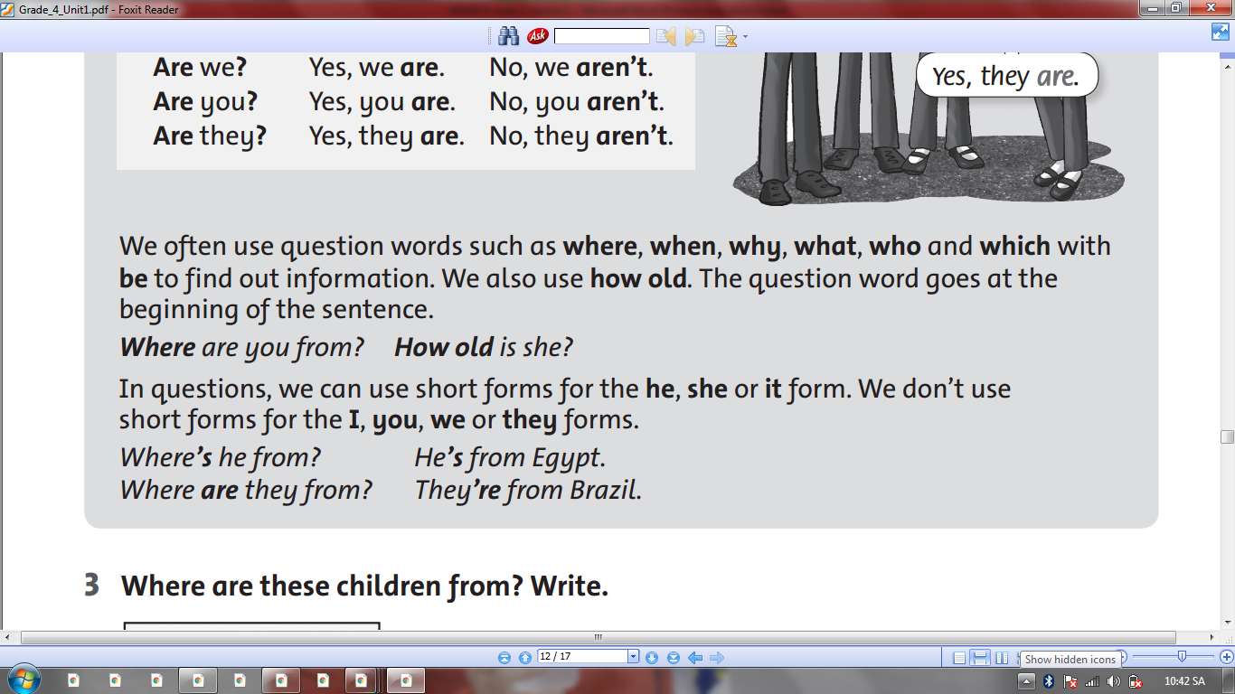

**EXERCISE**

# 1.Look and write

|  |
| --- |
| Korea Viet Nam Mexico Thailand Australia the U.S.A Brazil Japan |

|  |  |  |
| --- | --- | --- |
|  | Káº¿t quáº£ hÃ¬nh áº£nh cho thailand clipart | Káº¿t quáº£ hÃ¬nh áº£nh cho Vietnam clipart |
| **They are from Korea .** | She is from __________. | They are from ________. |
| HÃ¬nh áº£nh cÃ³ liÃªn quan | HÃ¬nh áº£nh cÃ³ liÃªn quan | HÃ¬nh áº£nh cÃ³ liÃªn quan |
| He is from __________. | She is from __________. | They are from ________. |
| HÃ¬nh áº£nh cÃ³ liÃªn quan | Káº¿t quáº£ hÃ¬nh áº£nh cho mexico clipart | HÃ¬nh áº£nh cÃ³ liÃªn quan |
| They are from __________. | He is from __________. | He is from __________. |

**2.Write**

|  |
| --- |
| We’re She’s He’s They’re |

1.Tony is seven years old. _________ from England.

2.Lily is nine years old. ____________ from Australia.

3.Nam and I are friends . _______________ from Viet Nam.

4.Anna and Lily are sisters . _______________ from the U.S.A.

**3.Write questions and answers**.

|  |  |  |
| --- | --- | --- |
| Káº¿t quáº£ hÃ¬nh áº£nh cho thailand cartoon images | is/Where/Anna/from ?  *……………………………………* | from/She/is/Thailand./  *……………………………………* |
| HÃ¬nh áº£nh cÃ³ liÃªn quan | is/Where/John/from ?  *……………………………………* | from/He/is/England./  *……………………………………* |
| HÃ¬nh áº£nh cÃ³ liÃªn quan | they/Where/are/from ?  *……………………………………* | They/are/Brazil./from/  *……………………………………* |
| Káº¿t quáº£ hÃ¬nh áº£nh cho mexico clipart | is/Where/Lucas/from ?  *……………………………………* | from/He/is/Mexico./  *……………………………………* |
| HÃ¬nh áº£nh cÃ³ liÃªn quan | /Where/Jeong/from ?/is  *……………………………………* | from/She/is/Korea./  *……………………………………* |

**4 .Read and write :**

|  |  |  |
| --- | --- | --- |
| is | are | am |

|  |  |  |
| --- | --- | --- |
| HÃ¬nh áº£nh cÃ³ liÃªn quan | Káº¿t quáº£ hÃ¬nh áº£nh cho mexico clipart | Káº¿t quáº£ hÃ¬nh áº£nh cho thailand clipart |
| I _______ from England. | He _______ from Mexico. | She _____ from Thailand. |
| HÃ¬nh áº£nh cÃ³ liÃªn quan | HÃ¬nh áº£nh cÃ³ liÃªn quan |  |
| I _______ from the U.S.A. | They ______ from Brazil. | They ______ from Korea . |

**COPY WORDS**

**Korea ______________________________________________________________________________________________________________________________________________________________________________________________________________________________**

**Vietnam**

**______________________________________________________________________________________________________________________________________________________________________________________________________________________________**

**Mexico**

**______________________________________________________________________________________________________________________________________________________________________________________________________________________________**

**Thailand**

**______________________________________________________________________________________________________________________________________________________________________________________________________________________________**

**Australia**

**______________________________________________________________________________________________________________________________________________________________________________________________________________________________**

**The USA**

**______________________________________________________________________________________________________________________________________________________________________________________________________________________________**

**Brazil ______________________________________________________________________________________________________________________________________________________________________________________________________________________________**